**Documentation**

Computer Networks, CSE 5344-002

**Name: Ritesh Deshmukh**

* This project is implemented using Python as a programming language.
* The attached code requires Python of version 3.5.2 installed on your system.
* To run the attached python files, open command prompt, migrate to the directory containing the files and type the following> python filename.py host port
* First run server.py and then client.py.
* After running the server, to open the files present in the server in a browser, type> host:port/filename
* Comments are provided in the attached code for explanatory basis.
* The screenshots of the runtime of the code are provided below.
* References are provided at the end of this document.

Before the server and client run using their host and port numbers:

To run server:

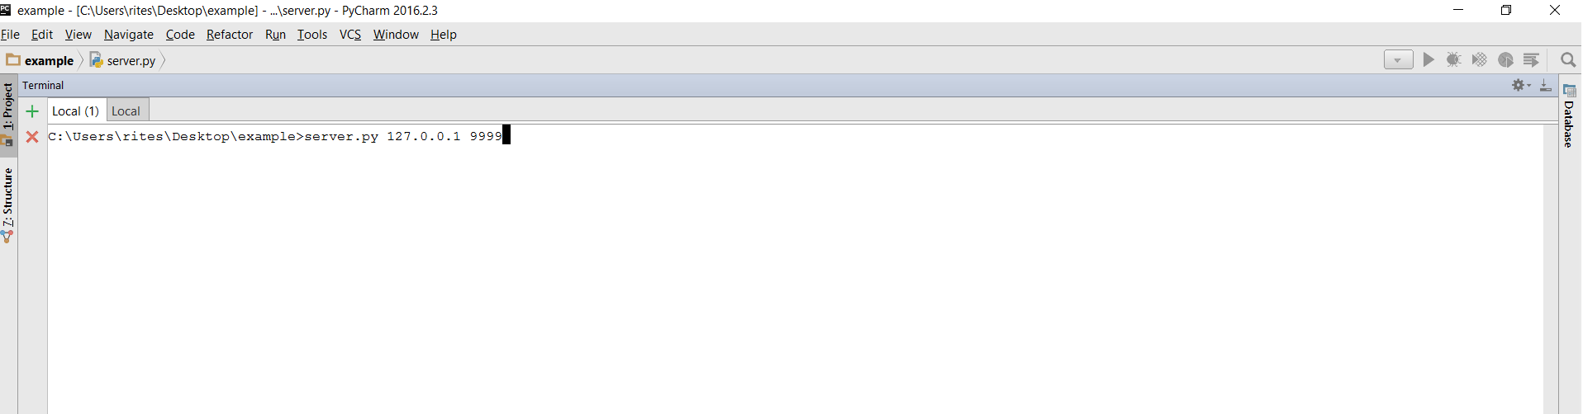

To run client:

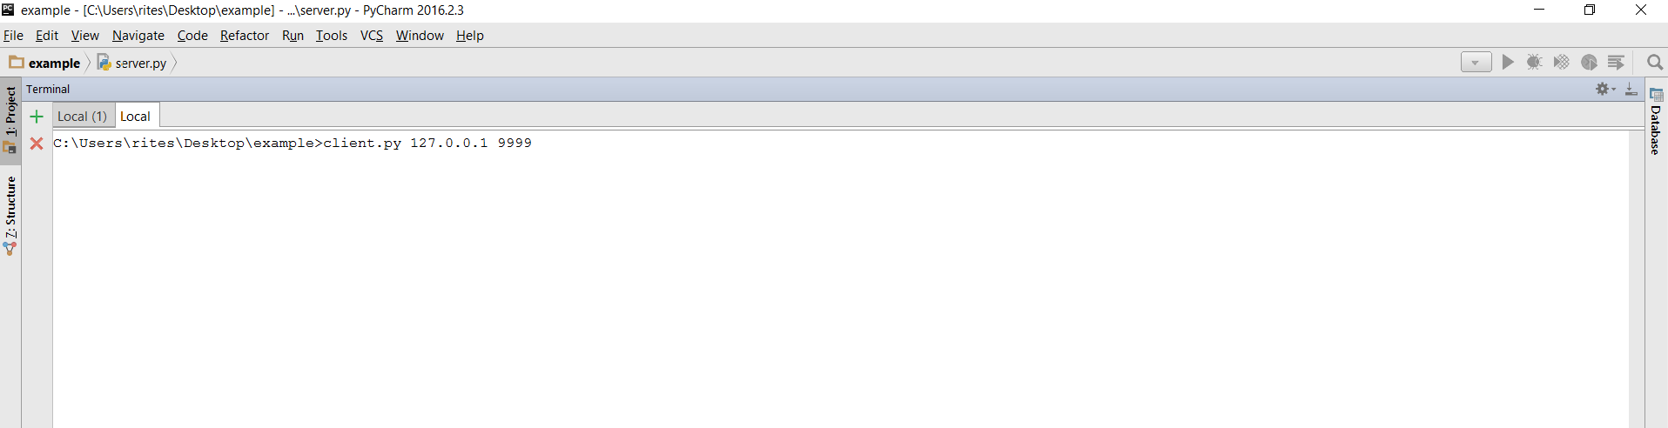

Displaying the client details on the server after the server has been started (here we have used the localhost with post no. 9999):

Here, the details of the client connected to the server are shown.

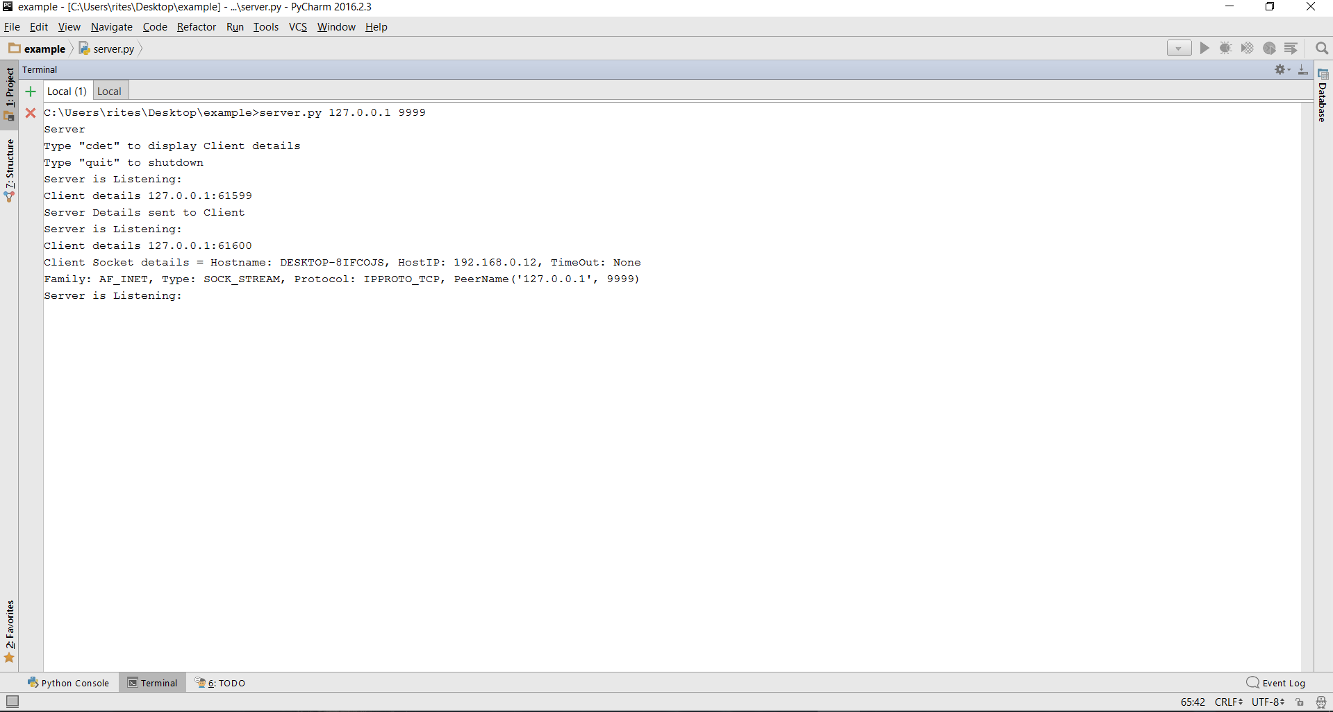

Displaying all the features on the client side after the client has been started:

The following screenshot shows the commands to use the features. The server details, sending client details to the server, the files present on the server, displaying a particular file and also calculating the rtt are shown. 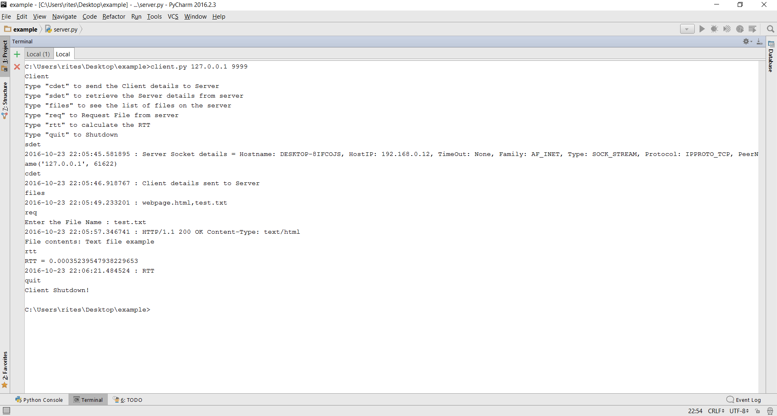

After the server is running, here is how the files are opened in the browser (Google Chrome is being used in this case):

File: test.txt

File: webpage.html

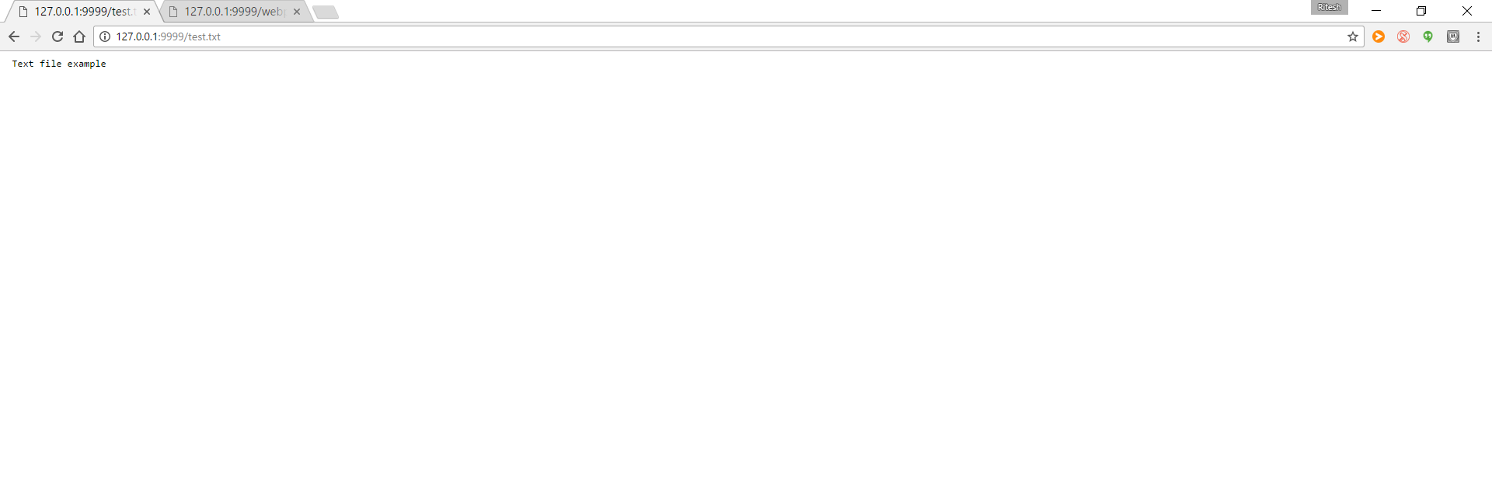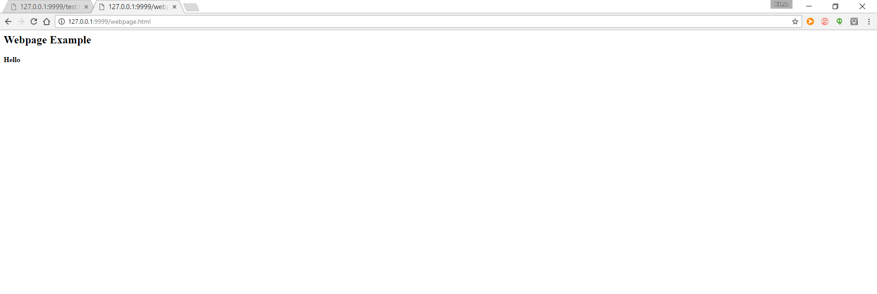

References:

Some parts of the code were taken as reference from the websites such as stackoverflow.com and docs.python.org